create database deneme

use deneme

create table ogrenciler(

ogr_no int,

adi varchar(25),

soyadi varchar(25))

create table ogrencileryeni(

kayit_no int not null ,

ogr_no int not null identity(20201000,1),

adi varchar(25),

soyadi varchar(25))

bir tabloda 2 tane identity olmaz.

create table degisken_deneme(

kayit_no int not null identity(1,1) primary key,

adi varchar(15),

soyadi varchar(15),

Puani int not null

)

select * from degisken_deneme

insert degisken_deneme values('harun','bakirci',100)

insert degisken_deneme values('ecrin','bakirci',90)

primary key identity(1,1) ile kullanılabilir.

**Kolon ismi değiştirme:**

Sp_rename ‘tabloadı.kolon adı’,’verilecek kolon ismi’,’kolon olarak işlem yaptığımı belirityorum’

sp_rename 'YeniTablo.sıra','sıra_no','column'

**Tablo ismi değiştirme:**

Sp_rename‘eski tablo adı’,’değiştirmek istediğim tablo adı’

sp_rename 'yenitablo','VeriTablom'

**Constraintler kısıtlayıcılardır.**

constraint tipleri:

**default constraint** belirtilen kolonun boş geçilmesi durumunda girilecek olan değer.

Constraintlerin genel yapısı:

Add constraint [constraint adı] Default ‘varsayılan değer’ for [kolon adı]

select * from YeniTablo

alter table YeniTablo alter column maas int

insert into YeniTablo(adi,soyadi) values('recep','bakirci')

alter table YeniTablo add constraint maasConstraint default 0 for maas

--burada 0 dedim çünkü maas kolonum int eger yazı yazarsam bu constrainti silmek zorunda kalırım

--eger constraint atayacağım kolon varchar olsaydı default olarak belirtilmemiş yazabilirdim.

insert into YeniTablo(adi,soyadi) values('cem','denktaş')

**primary key constraint** ekleme :

alter table YeniTablo add constraint PrimarySıra_no primary key (sıra_no)

tabloların altında constraints seçeneğinde o tabloda bulunan constraintleri görebilir. Delete ederek silebilirsin.

Default tan önce veri türünü gir.

create table ogrenci(

kayit_no int unique,

ogr_no int identity(20201001,1) primary key,

adi varchar(25),

soyadi varchar(25),

dogum_yeri varchar(25) default 'Belirtilmemiş.')

create table ogrenci(

kayit_no int unique,

ogr_no int identity(20201001,1) primary key,

adi varchar(25),

soyadi varchar(25),

dogum_yeri varchar(25) default 'Belirtilmemiş.')

select * from ogrenci

create table ogrenci100(

kayit_no int ,

ogr_no int identity(20201001,1) ,

adi varchar(25),

soyadi varchar(25),

dogum_yeri varchar(25) default 'Belirtilmemiş.'

constraint BA primary key(kayit_no,ogr_no))

create table notlar(

ogr_no int identity(20201001,1) ,

ders_kodu int,

vize int check (vize>0 and vize<=100),

final int check(final>0 and final<=100),

constraint BA1 primary key(ogr_no,ders_kodu))

select * from notlar

select * from ogrenci100

--ogrenci100 tablosunda dogum yeri default olarak belirtilmemiştir.

--veri girişi yaparken bu şekilde girersen belirtilmemiş yazar ama veri girişi yaptığın

--sutunları belirt.

insert into ogrenci100(kayit_no,adi,soyadi) values(4,'mert','sis')

create table urunler(

urun_kod varchar(4) not null,

urun_ad varchar(25) not null,

constraint chk check (urun_kod IN ('A089','A090 ','A091')))

create table urunlerYeni(

urun_kod varchar(4) not null,

urun_ad varchar(25) not null,

constraint chkyeni check (urun_kod like ('A9[0-9][0-9]')))

create table urunlerdeneme1(

urun_kod varchar(6) not null,

urun_ad varchar(25) not null,

constraint chkdeneme check (urun_kod like ('A9 [0-9] [0-9]')))

create table OGR(

ogr_no varchar(8) not null,

ogr_ad varchar(25) not null,

constraint chkogr check(ogr_no like ('2020[0-9][0-9]') or ogr_no in('19990000','19990001','19990002')))

drop table notlar

yeni ilişki oluşturma:

use deneme

create table ogrenci(

ogr_no int primary key,

adi varchar(25),

soyadi varchar(25),

bolum varchar(3))

create table ders(

ders_kodu varchar(5) primary key,

ders_adi varchar(25))

create table notlar(

ogr_no int,

ders_kodu varchar(5),

vize int,

final int,

constraint fk foreign key (ogr_no) references ogrenci(ogr_no),

constraint fk1 foreign key (ders_kodu) references ders(ders_kodu))

on update cascade on delete cascade kullanmazsam veriyi silemem ama bunu yazarsam

örneğin bir öğrenciyi silersem ya da bir dersi silersem o ders ve öğrenciyle alakalı bütün verileri siler

yazmazsam silmeye izin vermez.

create table notlar(

ogr_no int,

ders_kodu varchar(5),

vize int,

final int,

constraint fk foreign key (ogr_no) references ogrenci(ogr_no) on update cascade on delete cascade,

constraint fk1 foreign key (ders_kodu) references ders(ders_kodu) on update cascade on delete cascade)

burada kolonu parantez içerisine almayı sakın unutma.

constraint fk1 foreign key (ders_kodu) references ders(ders_kodu) on update cascade on delete cascade

listemde olan filmlerden satılanları çıkarıyorum satılmayan filmler kalıyor.

küme farkı:

select film_adi from Film

except

select f.Film_Adi from Satislar s inner join Film f on f.Film_No = s.Film_No

film database’i

create table Film(

Film_No int identity(1,1) primary key,

Film_Adi varchar(25) ,

Fiyat int,

Film_Turu varchar(25),

Film_Puanı int,

Yonetmen varchar(25),

constraint chk_puan check(Film_Puanı>=1 and Film_Puanı<=10))

create table Musteriler(

Musteri_ID int identity(202000,1) primary key not null,

Ad varchar(25),

Soyad varchar(25),

Cinsiyet varchar(5) not null,

Dogum_Tarihi datetime,

constraint chkcins check(Cinsiyet in ('Erkek','Kadın')))

create table Satislar(

Musteri_no int ,

Film_No int,

Tarih datetime,

Odeme_Turu varchar(15),

constraint FK_FilmNo foreign key (Film_No) references Film(Film_No),

constraint FK_MusteriNo foreign key (Musteri_No) references Musteriler(Musteri_ID),

constraint chckOdeme check(Odeme_Turu in('Kredi Kartı','Nakit')))

select film_adi from Film

except

select f.Film_Adi from Satislar s inner join Film f on f.Film_No = s.Film_No

**INTERSECT:** SQL’de INTERSECT ifadesini iki kümenin ortak elemanlarını getirmek için kullanırız.

SELECT Sutun1, Sutun2...., SutunN FROM Tablo1

INTERSECT

SELECT Sutun1, Sutun2...., SutunN FROM Tablo2

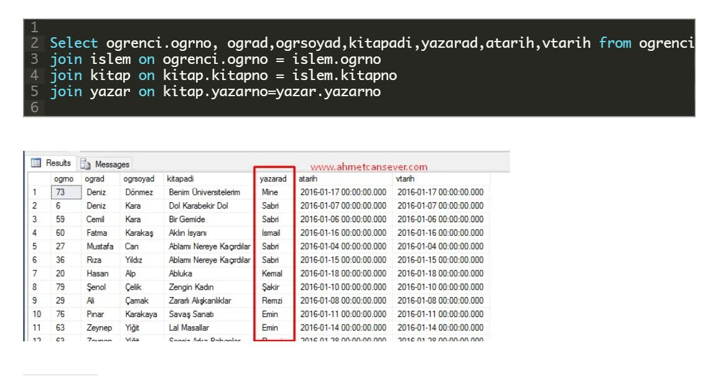

Yeni ders

use deneme

alter table ogrenciler add dogum_tarihi date not null default '1995'

select * from ogrenciler

alter table ogrenciler add unique(d_yeri)

alter table ogrenciler add tc_kimlik int

alter table ogrenciler add constraint unq unique(ogr_no,tc_kimlik)

create table ogrenciler1001(

ogr_no int not null,

adi varchar(25),

soyadi varchar(25),

d_yeri varchar(20))

alter table ogrenciler1001 add constraint prm primary key(ogr_no)

alter table ogrenciler1001 add constraint fky foreign key(ogr_no) references ogrenci(ogr_no)

alter table ogrenciler1001 add check (ogr_no>=2019000)

----tablodaki butun degerleri siler

truncate table öğrenciler

order diye fonksiyonum olduğu için bu Order sütununu ya ismini değiştiririm ya da parantez içerisinde yazarım.

select * from [Order]

select * from customer

SELECT column_name

FROM fabrika.INFORMATION_SCHEMA.COLUMNS

WHERE TABLE_NAME = 'customer'

select firstname,lastname,country from Customer

select Customer.City,Customer.FirstName,Customer.Phone from Customer

------ Kartezyen çarpımı olarak doner.

select customer.FirstName as 'MusteriAdi' , Supplier.Country from Customer , Supplier

select * from Customer

select count(OrderDate) as 'sayı' from [Order]

select count(distinct(OrderDate)) as 'benzersizSayı' from [Order]

select distinct(Package) from Product

select top 5 ıd,CustomerId,TotalAmount from [Order] order by TotalAmount desc

select * from Customer order by FirstName,country desc

select * from Customer order by FirstName,country asc

---- sutun numarası vererek de sorgulama yapabiliriz.

select * from customer order by 5,4 desc

select Id ,city as 'Şehir' ,country as 'Ülke' from Customer

select firstname +SPACE(1) + lastname as 'İsim-Soyisim' from Customer

select Id , ProductName , UnitPrice , UnitPrice*1.18 as KdvDahil from Product order by UnitPrice desc

ders 21.12.2020

use fabrika

select * from product where SupplierId=1 AND UnitPrice<22 AND Package='24 - 12 oz bottles'

select * from Customer where FirstName= 'pa[o]%'

select * from Customer where FirstName not like 'maria'

select * from Customer where not FirstName = 'maria'

select * from Customer where FirstName like '_[^a]%'

select * from Customer where FirstName in ('maria','paula','john')

--ismi bunların dışında olanları sıralar

select * from Customer where FirstName not in ('maria','paula','john')

select * from OrderItem where UnitPrice>=9 and UnitPrice<=10

select * from OrderItem where UnitPrice between 9 and 10

select * from Customer where FirstName like '[a-c]%'

select * from Customer where FirstName like '%a%'

select * from Customer where FirstName like 'a%'

select * from Customer where FirstName like '%a'

select * from Customer where FirstName like '____'

select * from Customer where FirstName like '[l,e]%'

select * from Customer where FirstName like '[a-d]%'

select * from Customer where Id like '[2-3][0-9]'

select * from Customer where Id between 20 and 39

select * from Customer where FirstName like '[^a,^b]%'

select * from Customer where FirstName like '[^a-b]%'

select * from Customer where FirstName not like '[a,b]%'

select * from Supplier where fax is null

select * from Supplier where fax is not null

select * from Customer

set identity customer on ---identity varsa ekleme yapar

set identity customer of -- dışarodan veri girişini kapatır.

insert into customer values('Harun','BAKIRCI','Turkey','İstanbul','0538 635 83 97')

select * from Customer where FirstName like 'a%'

select * from Customer where FirstName like '%a'

select * from Customer where FirstName like '____'

select * from Customer where FirstName like '[l,e]%'

select * from Customer where FirstName like '[a-d]%'

select * from Customer where Id like '[2-3][0-9]'

select * from Customer where Id between 20 and 39

select * from Customer where FirstName like '[^a,^b]%'

select * from Customer where FirstName like '[^a-b]%'

select * from Customer where FirstName not like '[a,b]%'

select * from Supplier where fax is null

select * from Supplier where fax is not null

select * from Customer

set identity customer on ---identity varsa ekleme yapar

set identity customer of -- dışarodan veri girişini kapatır.

insert into customer values('Harun','BAKIRCI','Turkey','İstanbul','0538 635 83 97')

select * from Customer

update customer set City='Barcelona' ,country='Spain' where City='Turkey'

select * from Supplier

select * from Customer

update Supplier set Fax='Belirtilmemiş' where Fax is null

select ISNULL(fax,'Belirtilmemiş') as Fax from Supplier

delete from Customer where RIGHT(firstname,2) =

--- isminin son iki harfi un olanları sil

delete from Customer where FirstName like '%un'

insert into customer values('Harun','BAKIRCI','Turkey','İstanbul','0538 635 83 97')

select * from Customer

--- sildikten sonra ıd numarasını baştan başlatmaz en son sildiğin id ne ise onunla devam eder

---or 95 id li en kayıdı sildiniz yeni kayıt 96 olarak algılanır bunu önlemek için truncate ekle

---delete from customer id numarası gibi kalıntıları hatırlar

--- truncate customer dersek tablodaki herşeyi siler

use fabrika

select Country ,city , count(ıd) as MusteriSayisi from Customer group by Country ,City

select Country ,city , count(City) as MusteriSayisi from Customer group by Country ,City

select Country , count(ıd) as MusteriSayisi from Customer group by Country

select OrderId, count(OrderId) as A from OrderItem group by OrderId having count(OrderId) = 3

SELECT Country, COUNT(Id) as ToplamMusteriSayisi FROM Customer WHERE Country <> 'USA'

GROUP BY Country HAVING COUNT(Id) >= 9 ORDER BY COUNT(Id) DESC

SELECT Country, COUNT(Id) as ToplamMusteriSayisi FROM Customer

GROUP BY Country HAVING COUNT(Id) >= 9 and Country NOT like 'USA' ORDER BY COUNT(Id) DESC

select * from Supplier

select * from Customer

select c.Id , s.CompanyName from Customer c inner join Supplier s on c.Id = s.Id

select c.Id , s.CompanyName from Customer c inner join Supplier s on c.Id = s.Id where c.Id>10

select * from Customer where Customer.Id =(select CustomerId

from [Order] where TotalAmount=6750)

select * from Customer where Customer.Id =(select CustomerId

from [Order] where TotalAmount=45)

select * from [Order]

select * from Customer

select top 1 UnitPrice from Product where Package = '24 - 12 oz bottles' order by UnitPrice

select Package ,UnitPrice from Product where UnitPrice <

(select top 1 UnitPrice from Product where Package = '24 - 12 oz bottles' order by UnitPrice) order by UnitPrice

select * from Product where UnitPrice <

(select top 1 UnitPrice from Product where Package = '24 - 12 oz bottles' order by UnitPrice)

select * from [Order] where TotalAmount < (select avg(TotalAmount) from [Order]) order by TotalAmount

---içiçe sorguda kesinlikle () koy

select * from Product

select * from Customer

--- birden fazla müşteri oldugu için in kullandım.

select * from Customer where Customer.Id in

(select [Order].CustomerId from [Order] where TotalAmount > (select avg(TotalAmount) from [Order]))

select * from Customer where Customer.Id in

(select Product.Id from Product where Product.ProductName='Ikura')